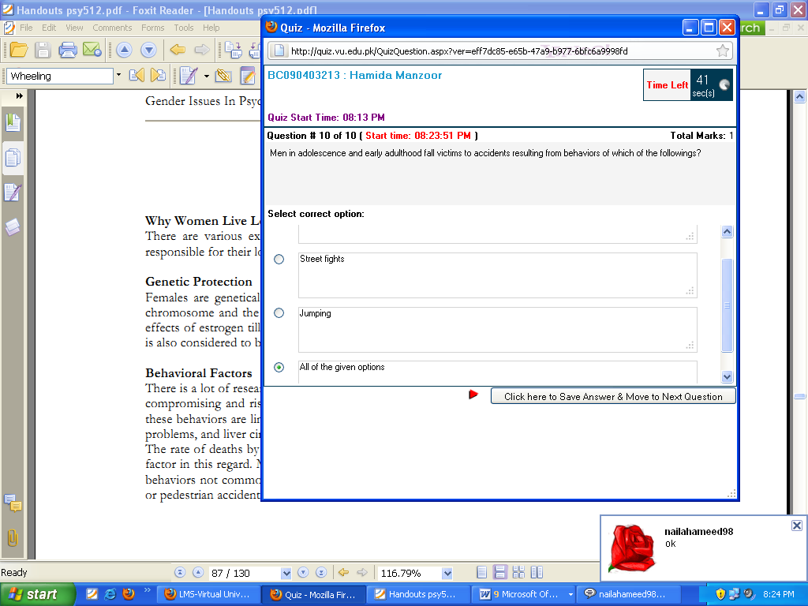

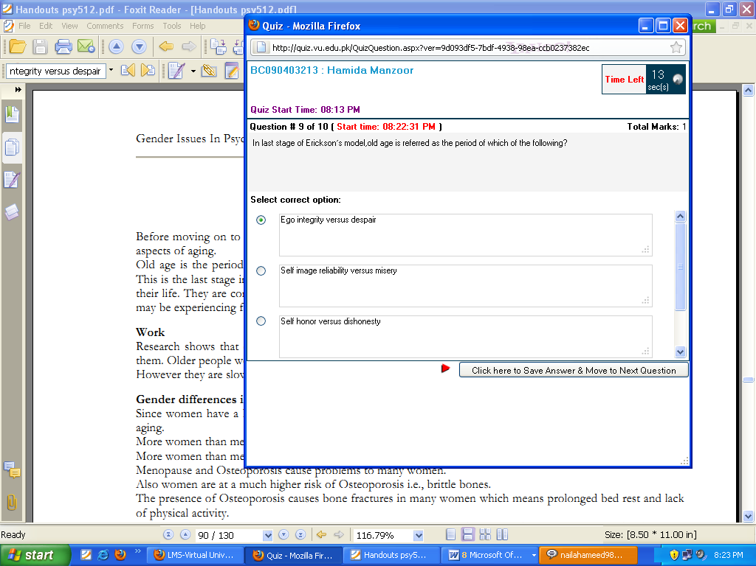

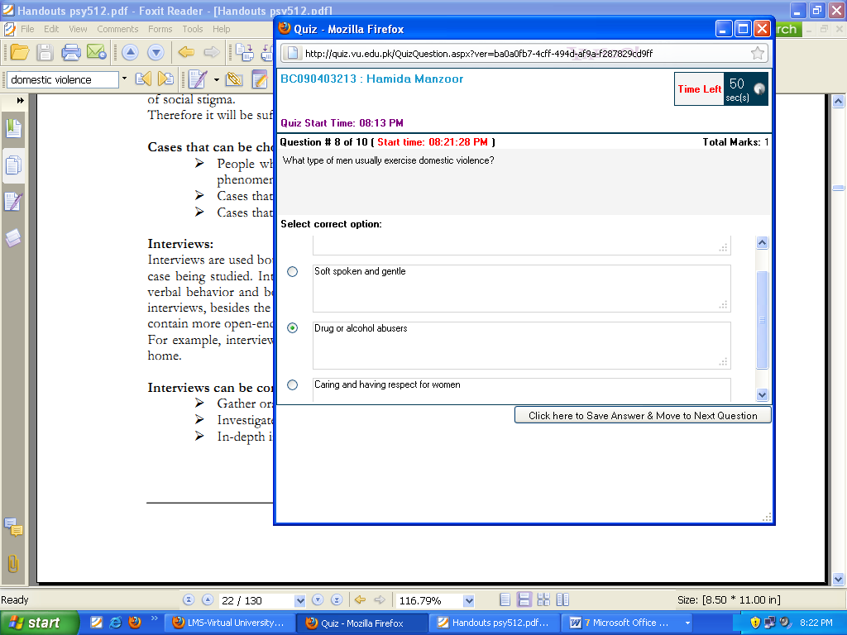

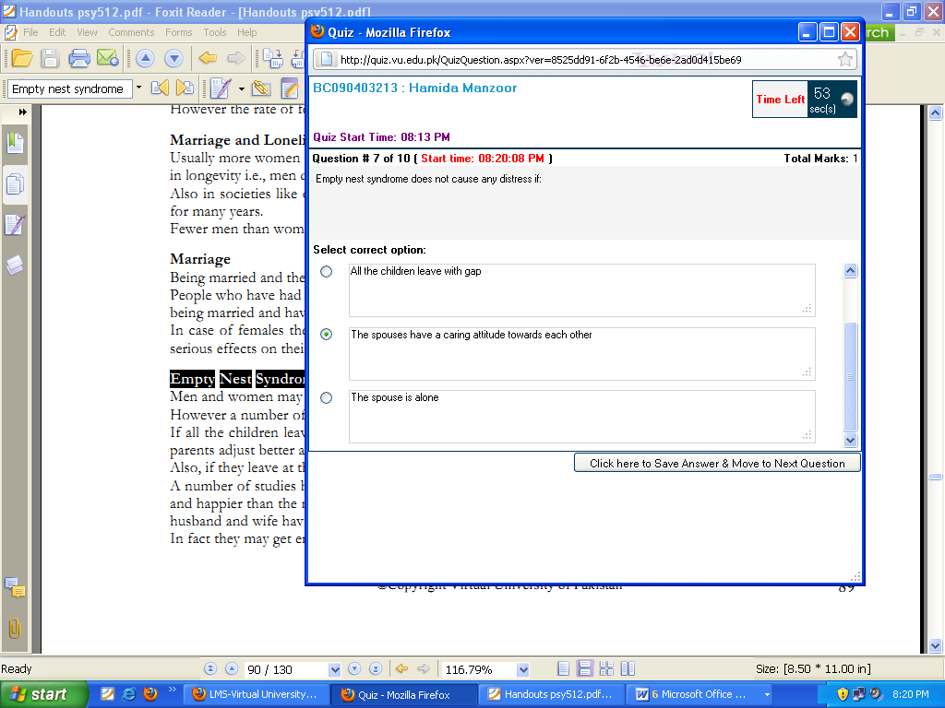

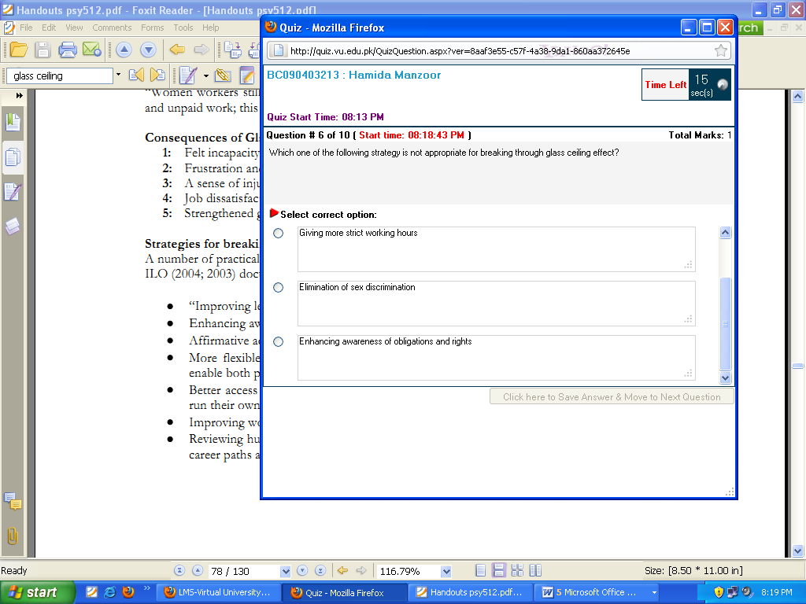

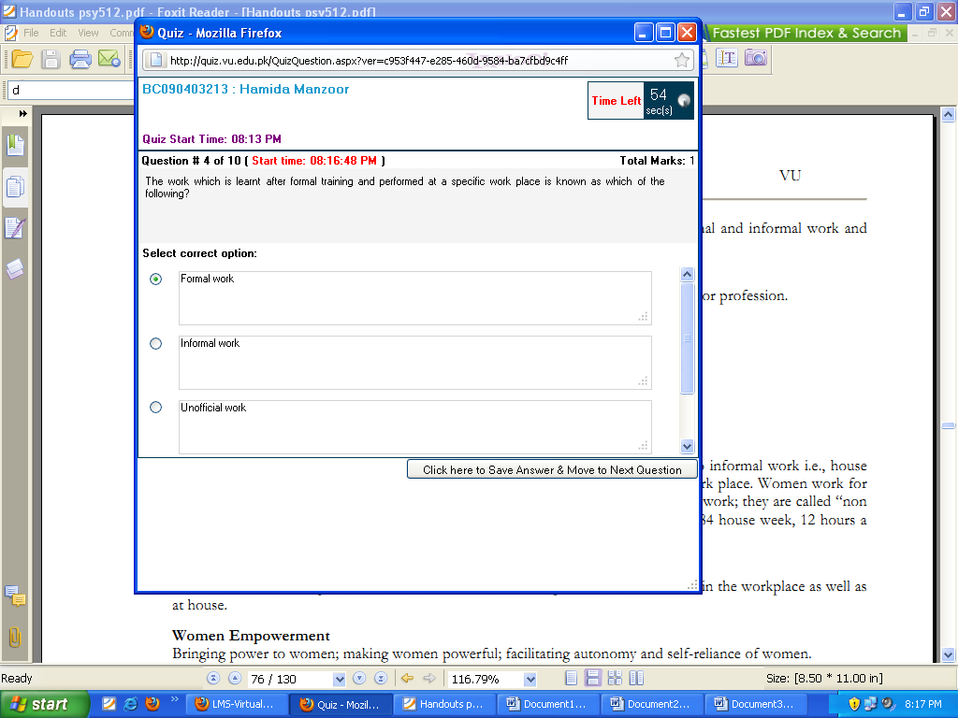
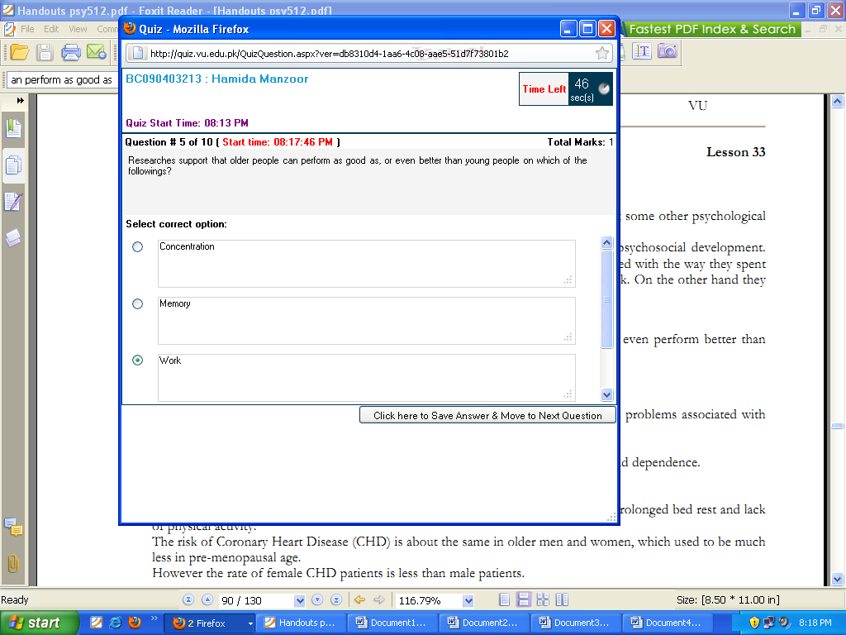


Research proves that when male teachers are teaching, there is __________ gender stereotyping.

Select correct option:


Which of the following subjects is stereotypically perceived as a male domain?

Select correct option:

There is always a greater likelihood that in movies men will be NOT depicted as:

Select correct option:

TV commercials are one another source of promoting male and female images that may not have much to do with________________.

Select correct option:

Electronic media includes all of the followings EXCEPT:

Select correct option:

Which of the followings is an important element in female friendships?

Select correct option:

Media has a direct impact upon an individual’s personality, particularly which of the following?

Select correct option:

No matter how small the gender differences in ___________may be, they are generally skewed in favor of males.

Select correct option:

Comparing work hours, on average a housewife works _____________ than an average man does.

Select correct option:

The exchange of informational and emotional support with friends is found higher in_____________?

Select correct option:

Top of Form
Women are thought to be more:
Select correct option:




Bottom of Form
Electronic media includes all of the followings EXCEPT:
Select correct option:
Top of Form
Media has a direct impact upon an individual’s personality, particularly which of the following?
Select correct option:

Bottom of Form
Top of Form
use which kind of aggression mostly?
Select correct option:

Bottom of Form
Top of Form
Research proves that when male teachers are teaching, there is __________ gender stereotyping.
Select correct option:

Bottom of Form
No matter how small the gender differences in ___________may be, they are generally skewed in favor of males.
Select correct option:
Top of Form
Men are thought to be more:
Select correct option:

Bottom of Form
Top of Form
Electronic media includes all of the followings EXCEPT:
Select correct option:

Bottom of Form
Top of Form
is always a greater likelihood that in movies men will NOT be depicted as:
Select correct option:

Bottom of Form
Women use a more speech pattern but the way women talk, leads others to evaluate them as what of the followings?
Select correct option:
Women use a more speech pattern but the way women talk, leads others to evaluate them as what of the followings?
Select correct option:

Top of Form
Women are thought to be more:
Select correct option:

Bottom of Form
Electronic media includes all of the followings EXCEPT:
Select correct option:
Top of Form
Media has a direct impact upon an individual’s personality, particularly which of the following?
Select correct option:

Bottom of Form
Top of Form
use which kind of aggression mostly?
Select correct option:

Bottom of Form
Top of Form
Research proves that when male teachers are teaching, there is __________ gender stereotyping.
Select correct option:

Bottom of Form
No matter how small the gender differences in ___________may be, they are generally skewed in favor of males.
Select correct option:
Top of Form
Men are thought to be more:
Select correct option:

Bottom of Form
Top of Form
Electronic media includes all of the followings EXCEPT:
Select correct option:

Bottom of Form
Top of Form
is always a greater likelihood that in movies men will NOT be depicted as:
Select correct option:

Bottom of Form
Women use a more speech pattern but the way women talk, leads others to evaluate them as what of the followings?
Select correct option:
Women use a more speech pattern but the way women talk, leads others to evaluate them as what of the followings?
Select correct option:

